FINAL YEAR B.TECH. INTERNSHIP REPORT
A report submitted in partial fulfillment of the requirements for the Award of
Degree of
BACHELOR OF TECHNOLOGY
in
COMPUTER SCIENCE AND ENGINEERING
By
Vinay
Under the Supervision of
Mr. Adwaith Gupta, Founder & Manager, Paanduv Applications Pvt. Ltd.
Internship Period: 5th January 2026 to 5th July 2026


DECLARATION
I solemnly declare that the report is based on my own work done on Backend Development and Software Engineering for an Additive Manufacturing Simulation Platform, completed during the internship at Paanduv Applications Pvt. Ltd. under the supervision of Mr. Adwaith Gupta from 22/04/2026 to 22/07/2026.
All the data provided regarding the project is accurate to the best of my knowledge and detailed only as much as I am permitted to share by the organization. Certain product names, internal architecture details, and proprietary algorithmic specifics have been generalized or anonymized to comply with the confidentiality terms of the internship.
I assert that the statements made and conclusions drawn are an outcome of my own work. I further certify that:
- The work contained in this report is original and has been done by me under the general guidance of my supervisor.
- I have followed the guidelines provided by the Institute in writing this report.

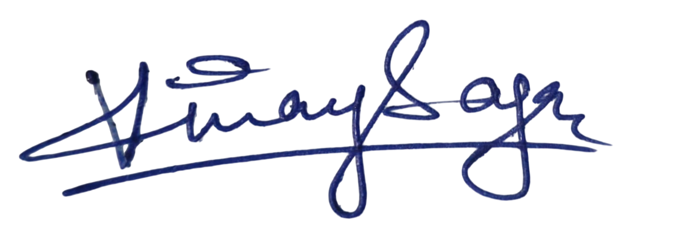
Vinay Sagar
BT22CSE041

ACKNOWLEDGEMENT
I would like to express my sincere gratitude towards Mr. Adwaith Gupta, Founder & Manager of Paanduv Applications Pvt. Ltd., for giving me the opportunity to work on a real industrial software product, and for his consistent technical guidance, patient mentorship, and willingness to share his decades of mechanical-engineering expertise throughout the internship.
I extend my appreciation to the entire Research & Development team at Paanduv Applications Pvt. Ltd. particularly the senior developers and the Applied Research team, whose patience in explaining the underlying physics of additive manufacturing made this internship far more than a software engineering exercise. Their willingness to involve me in design reviews, debugging sessions, and client deployment discussions enabled the broad scope of work reflected in this report.


Vinay Sagar
BT22CSE041

TABLE OF CONTENTS

Declaration | i
Acknowledgement | ii
1. Internship Details | 1
1.1 Organization Name | 1
1.2 Business Profile | 1
1.3 Internship Profile / Role | 2
2. Introduction of Projects / Modules | 3
3. Tools and Technology Learnt | 5
4. Technical Details of the Projects / Modules Completed | 7
4.1 Module 1, AM PravaH LPBF Module for Distributed (HPC) Execution | 11
4.2 Module 2, WSL 2 Windows Port | 9
4.3 Module 3, Docker Deployment | 13
4.4 Module 4, Pack Density Modeling | 15
4.5 Module 5, Solver Feature Integration | 18
4.6 Module 6, UI Refinement | 20
5. Results and Discussion | 21
6. Challenges and Learnings | 23
7. Outcome | 24
8. References | 25

1. INTERNSHIP DETAILS
This section provides the details of the organization where the internship was undertaken. It describes the business profile of the company and my designated role as an intern, along with the structure of the team I was embedded in.

1.1 Organization Name
Paanduv Applications Pvt. Ltd. (Registered Office: 124 Parwana Nagar, Uttar Pradesh 243122).

1.2 Business Profile
Paanduv Applications Pvt. Ltd. provides low cost, sustainable, and state-of-art physics-based computational software development services, consulting services and hands-on educational services across industries, academia and research labs. These industries include Additive Manufacturing, Electric Vehicle, Data Center, Chemical Engineering, Water and Environmental, Aerospace and Defense, Energy, Turbomachinery, Automotive, Mining, Microfluidics, Electronics, and Consumer Products.

1.3 Internship Profile / Role

1.3.1 Designation and Context
I joined Paanduv Applications Pvt. Ltd. on 22nd July 2026 as a Software Developement Intern, reporting directly to Mr. Adwaith Gupta, Founder & Manager. The internship is structured as a three-month engagement, concluding on 22nd July 2026, with a working schedule of Monday to Saturday, 8:00 AM to 5:00 PM. The role carries a monthly stipend of ₹10,000 along with company-provided accommodation.
The team I was assigned to is the Research & Development team, which is internally organized into two tightly-coupled sub-teams:
- Development Sub-Team: responsible for source code, software implementation, GUI development, and end-user-facing features of AM PravaH.
- Applied Research Sub-Team: responsible for the physics theory, numerical methods, internal solver validation, and reconciliation of simulation outputs against experimental data.
I was embedded in the Development sub-team but worked across the boundary regularly, many of the tasks I undertook required understanding the physical phenomena being simulated, which made informal collaboration with the Applied team an everyday occurrence.

1.3.2 Areas of Responsibility
My responsibilities, formalized in the offer letter as assisting in the design, development, testing, debugging, and maintenance of software applications, evolved into five major work streams over the course of the internship:
- User Interface Refinement: Improving the usability and visual structure of the existing Tkinter-based GUI.
- Solver Feature Integration: Merging new physics solver modules (Fluid Dynamics, Spreader Creation) developed by senior team members into the updated UI branch.
- Cross-Platform Porting via WSL 2: Porting the Linux-only software stack to Windows using Windows Subsystem for Linux 2, with an automated one-click installer.
- Pack Density Modeling Across Layers: Implementing the core algorithm that computes inter-layer pack density evolution during multi-layer powder spreading and melting simulations.
- Docker-Based Deployment: Containerizing the full software stack for consistent, reproducible deployment across Linux, Windows, and macOS.

1.3.3 Nature of Daily Work
A typical working day involved a structured mix of feature development, code review, debugging, and team discussion. Mornings usually began with a brief stand-up where ongoing work was synchronized across the Development sub-team, followed by deep-focus implementation work through the late morning and afternoon. Mid-week sessions frequently included joint discussions with the Applied Research team to clarify physics expectations before committing to an implementation approach.

2. INTRODUCTION OF PROJECTS / MODULES
This chapter introduces the five interconnected modules that structured the internship work, along with the OnCall client-support stream. These modules did not operate as isolated tasks, the output of one module routinely fed into another. UI refinements made the solver integration cleaner; the solver integration changed what the WSL 2 installer needed to deploy; pack density work consumed the integrated solvers; and the Docker deployment ultimately had to support all of the above.

2.1 Module 1: Tkinter UI Refinement
Background and Motivation: AM PravaH's user interface had grown organically across multiple developer generations, with each new feature added as a new panel or dialog without a unifying visual structure. End-users, typically mechanical engineers, not software specialists, found the resulting interface intimidating, with critical input fields buried in inconsistent locations and feedback during long-running simulations almost entirely absent.
Objective: To refine the existing Tkinter-based GUI to improve usability and reduce friction in the simulation setup workflow, without rewriting the underlying logic. The goal was a measurable improvement in how quickly a new user could go from a blank state to a configured, runnable simulation case.

2.2 Module 2: Merging Solver Features into the Updated UI Branch
Background and Motivation: While the UI refinement was happening on the develop/v3.0-ui branch, senior developers in the Applied team had continued adding new physics features, Fluid Dynamics and Spreader Creation modules, to older branches (legacy/v2.x) where the UI was simpler to modify. These features needed to be brought forward into the new UI branch without breaking either the new visual structure or the underlying solver logic.
Objective: To cherry-pick, refactor, and integrate the Fluid Dynamics and Spreader Creation modules into the updated UI branch, ensuring compatibility with the redesigned Tkinter widgets and end-to-end functional correctness across all affected workflows.

2.3 Module 3: Cross-Platform Porting to Windows via WSL 2
Background and Motivation: AM PravaH was originally developed and validated on Linux because the underlying OpenFOAM, DEM, and MPM solvers have first-class Linux support. However, the majority of SM Engineers' industrial customers run Windows-based engineering workstations, and asking them to install a separate Linux system was a significant barrier to adoption. Windows Subsystem for Linux 2 (WSL 2) presented an opportunity to deliver the full Linux solver experience on Windows without requiring dual-boot or virtualization.
Objective: To port the complete AM PravaH stack to Windows using WSL 2 as the runtime layer, packaged with an automated installer that hides the underlying complexity from the end user. The success criterion was that a non-technical engineer should be able to install and run AM PravaH on a fresh Windows 11 machine with a single double-click and no command-line interaction.

2.4 Module 4: Multi-Layer Pack Density Modeling
Background and Motivation: Powder-bed additive manufacturing is intrinsically a multi-layer process, a part is built up one thin powder layer at a time, with each layer fused by laser before the next is spread on top. The pack density of each fresh powder layer is one of the most important inputs to the downstream melting simulation, because it determines how much material is available to fuse and how heat propagates through the layer. While the first layer's pack density can be computed from straightforward geometric arguments, every subsequent layer is spread on top of a non-flat surface, the previously melted (and partially densified) layer beneath it. Correctly computing the pack density of the second and subsequent layers requires tracking how the bed surface shifts as material consolidates.
Objective: To implement the algorithm that computes pack density not just for the first powder layer, but for every subsequent layer, correctly accounting for the volumetric changes caused by melting of prior layers and the resulting geometric shifts in the available bed volume.

2.5 Module 5: Docker-Based Cross-Platform Deployment
Background and Motivation: While WSL 2 solved the Windows deployment problem, it left two challenges unaddressed: macOS users could not be supported at all, and even on Linux, AM PravaH required users to install and maintain a long list of dependencies (specific OpenFOAM versions, Python libraries, NumPy/SciPy versions, ParaView, and so on). A small change in any of these could break the software in subtle ways. Docker offered a way to package the entire runtime environment into a single immutable image.
Objective: To produce a production-ready Docker image and accompanying Dockerfile that bundles AM PravaH, all its solver dependencies, runtime configurations, and a working GUI-forwarding setup, enabling consistent deployment across Linux, Windows, and macOS environments.
Objective: To handle client installation issues during my OnCall weeks, escalate genuine bugs back to the team, and produce reusable troubleshooting documentation for the most commonly encountered problems.

3. TOOLS AND TECHNOLOGY LEARNT
The tools used during the internship spanned three broad categories: the application development stack itself, the scientific computing and simulation infrastructure underlying it, and the deployment and operations tooling required to ship it to customers. Listed below are the tools whose usage moved from textbook familiarity to genuine working competence over the course of the internship.

3.1 Python and the Tkinter Ecosystem
Python served as the primary application language for AM PravaH. While I had used Python extensively before, the internship deepened my familiarity with Tkinter and its themed widget extension ttk in production-scale contexts. I worked with the geometry managers (grid, pack, place) at a level of nuance that academic exercises rarely require, for example, understanding why a mixed grid-and-pack layout silently breaks responsiveness, and how to use ttk styles to maintain a consistent visual identity across dozens of dialog windows. PIL (Pillow) was used for image rendering in the visualization panels.

3.2 OpenFOAM (Computational Fluid Dynamics)
OpenFOAM is the open-source CFD framework that powers AM PravaH's melting and solidification simulations. I learned to read OpenFOAM case directory structures (constant/, system/, 0/), understand the role of boundary condition files, and trace runtime errors back to specific solver dictionaries. While the internship did not require me to write solver C++ code, it did require me to write Python wrappers that programmatically generate, modify, and read OpenFOAM cases, which required a working understanding of the framework's conventions.

3.3 DEM and MPM Solvers
Discrete Element Method (DEM) and Material Point Method (MPM) are two numerical methods used in AM PravaH for different physical regimes, DEM for the discrete particle dynamics of powder spreading, MPM for situations where a continuum description with embedded discrete features is appropriate. I gained working knowledge of the inputs each solver expects, the format of its outputs, and the meaning of its key configuration parameters, enough to integrate them into orchestration pipelines.

3.4 WSL 2 (Windows Subsystem for Linux)
WSL 2 was the runtime layer for the Windows port. Working on this module gave me genuine operational knowledge of WSL, distribution provisioning, file system bridging between Windows and the Linux guest, networking, the wslg GUI-forwarding subsystem, and the difference between WSL 1 and WSL 2 (the latter using a real Linux kernel in a managed virtual machine). I learned how to script WSL operations from PowerShell and how to detect and recover from common installation failure modes.

3.5 Docker and Container Workflows
For the cross-platform deployment work, Docker became central. I built multi-stage Dockerfiles, optimized image sizes by carefully ordering layer instructions, and worked through the surprisingly involved problem of forwarding a Tkinter GUI out of a Linux container to a Windows or macOS host. I also learned the operational cadence of tagging, pushing, and version-pinning images for client deployments.

3.6 Git and Branch Management
Git was used not only for version control but as the primary mechanism for coordinating work across the Development and Applied sub-teams. The Solver Feature Integration module required deep familiarity with cherry-picking, interactive rebasing, conflict resolution across large diffs, and the discipline of keeping commits small enough to be reviewable. I learned that effective branch management is, in practice, a communication skill as much as a technical one.

3.7 Shell Scripting and PowerShell
Both POSIX shell scripting (bash) and Windows PowerShell were used extensively in the installer and OnCall work. The installer logic for the WSL 2 port was, at its core, a chain of PowerShell calls coordinating Windows-side actions with bash scripts driving the Linux-side actions inside WSL.

3.8 NumPy, SciPy, and ParaView for Post-Processing
NumPy and SciPy were used in the pack density module for the volumetric and computational-geometry calculations, while ParaView was the primary visualization tool for inspecting simulation outputs. I learned ParaView's filter pipeline, how to scripts its operations via the pvbatch interface, and how to export visualizations programmatically for reporting.

4. TECHNICAL DETAILS OF THE PROJECTS / MODULES COMPLETED
This chapter provides the detailed operational and analytical account of the work undertaken in each of the modules described in Chapter 2. Before discussing each module individually, it is worth presenting the overall software architecture of AM PravaH, because every module touches one or more layers of this stack.
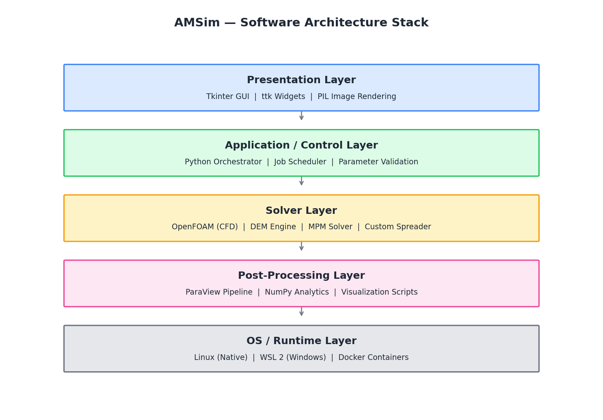
Figure 4.1: AM PravaH software architecture stack, spanning UI to OS-level runtime.
The presentation layer is built on Tkinter, with PIL handling image-rendering needs in visualization panels. The application/control layer is a Python orchestration tier that schedules solver runs, validates parameters, and bridges UI events to back-end actions. The solver layer hosts the actual scientific compute, OpenFOAM for CFD, DEM for powder dynamics, MPM for continuum-with-discrete-features regimes, and a custom spreader implementation. The post-processing layer turns raw solver output into figures and structured analytics using ParaView and NumPy. Finally, the OS/runtime layer is where the WSL 2 and Docker deployment work in Modules 3 and 5 lives.

4.1 Module 1, AM PravaH LPBF Module for Distributed (HPC) Execution

4.1.1 Problem Definition and Background
Laser Powder-Bed Fusion (LPBF) is the most computationally demanding process AM PravaH models. A single LPBF simulation couples melt-pool computational fluid dynamics, discrete-element powder mechanics, and multi-layer thermal history over a mesh that must be fine enough to resolve the melt pool itself. As the build grows, from a single track to multi-track, multi-layer geometries, the cell count and the number of solver time steps rise sharply, and with them the compute cost.
In its original form, AM PravaH's LPBF module ran only on a single system. The solver stack (OpenFOAM for the CFD, together with the DEM and MPM solvers) was parallelised with MPI across the cores of one workstation, a pure shared-memory arrangement confined to a single machine. This was entirely adequate for small, single-track studies, but it imposed two hard ceilings on larger production cases:
- Wall-clock time: the run could only ever use the cores of one machine, so realistic multi-layer builds took many hours to days to complete, regardless of how many other machines sat idle nearby.
- Memory capacity: a sufficiently large, high-resolution case simply did not fit in a single workstation's RAM, which put an upper bound on the size and fidelity of build that could be simulated at all.
The objective of this module was to lift both ceilings by enabling a single LPBF simulation to run across several networked machines, a High-Performance Computing (HPC) cluster, pooling their CPU cores and memory. The work had a strict constraint attached: the distributed capability had to be added without altering the physics, the input parameters, or the end user's workflow, and the existing single-machine mode had to remain available and behave exactly as before. The two execution modes were to be selectable through a simple toggle, so that the same case could be run on a single workstation for a quick check and on the cluster for the full build.

4.1.2 Implementation Approach
The work divided naturally into two parts: first, standing up a local HPC cluster on which distributed runs could execute; and second, extending AM PravaH's existing run logic so that it could target that cluster through an automatically generated SLURM job, chosen at run time by a toggle.
A. Standing up the local HPC cluster
A minimal but complete cluster was provisioned from ordinary Linux machines on a private network: one head (controller) node and several compute nodes, as shown in Figure 4.8. Four pieces of infrastructure make such a cluster function as a single system.
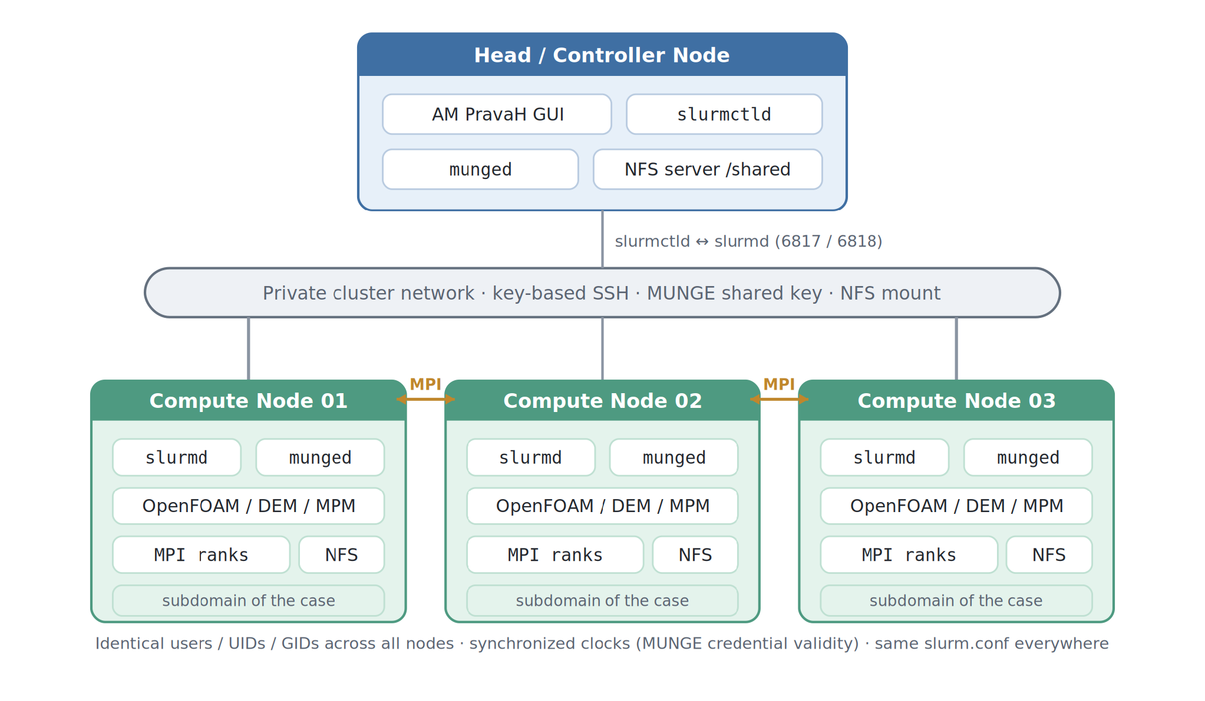
Figure 4.8: Local HPC cluster topology, one controller node coordinating several compute nodes over SLURM, MUNGE, SSH, and a shared filesystem.
- SLURM as the workload manager: SLURM (Simple Linux Utility for Resource Management) schedules and places jobs on the cluster. Its control daemon, slurmctld, runs on the head node and owns queueing, prioritisation, and resource allocation; a compute daemon, slurmd, runs on every compute node and is responsible for launching, monitoring, and, if necessary, terminating the processes of a job on that node.
- MUNGE for authentication: SLURM's daemons must trust one another across the network. MUNGE provides this by means of a single shared secret key, distributed identically to every node; its daemon, munged, signs each message on the sending node and verifies it on the receiving node, so a compute node only accepts work that genuinely originated from the controller. This is authentication rather than encryption, its role is to prove who sent a message and to map user and group identities consistently across the cluster.
- SSH for remote access: key-based, passwordless SSH was configured from the head node to every compute node. This allows the controller to provision nodes, run health checks, and launch the distributed solver processes without any interactive password prompt, which is a precondition for fully automated, unattended job execution.
- A shared filesystem: the head node exports a common directory over NFS, mounted at the same path on every node. Because the solver decomposes one case across the cluster and each node reads its own portion of the input and writes its own portion of the output, all nodes must see the identical case directory at the identical location, this shared mount is what makes that possible.
Three consistency requirements underpin the whole arrangement, and each later turned into a documented pre-flight check: every node must resolve the same users with the same UIDs and GIDs; the node clocks must be synchronised, because MUNGE credentials are valid only for a short window and any meaningful clock skew causes authentication to fail; and every node must carry the same SLURM configuration. Once provisioned, the cluster was verified independently of AM PravaH, confirming that all nodes reported as available and that a trivial multi-node test job launched and returned correctly, before any application code was wired in.
B. SLURM script logic and the execution backend
Rather than sprinkle cluster-awareness throughout the codebase, the existing “run the solver” step was placed behind a single execution-backend interface. Everything upstream of that interface, geometry, material and process setup, mesh generation, and the physics itself, remained untouched and entirely unaware of where the computation would ultimately run. Two backends were implemented behind the interface:
- The local backend: the pre-existing single-machine path, launching the solver with MPI across the local cores. This code path was deliberately left unchanged, so that single-system runs continue to behave precisely as they always had.
- The cluster backend: instead of invoking MPI directly, this backend takes the same run parameters the interface already provides and generates a SLURM batch script (Figure 4.10), which it then submits to the cluster.
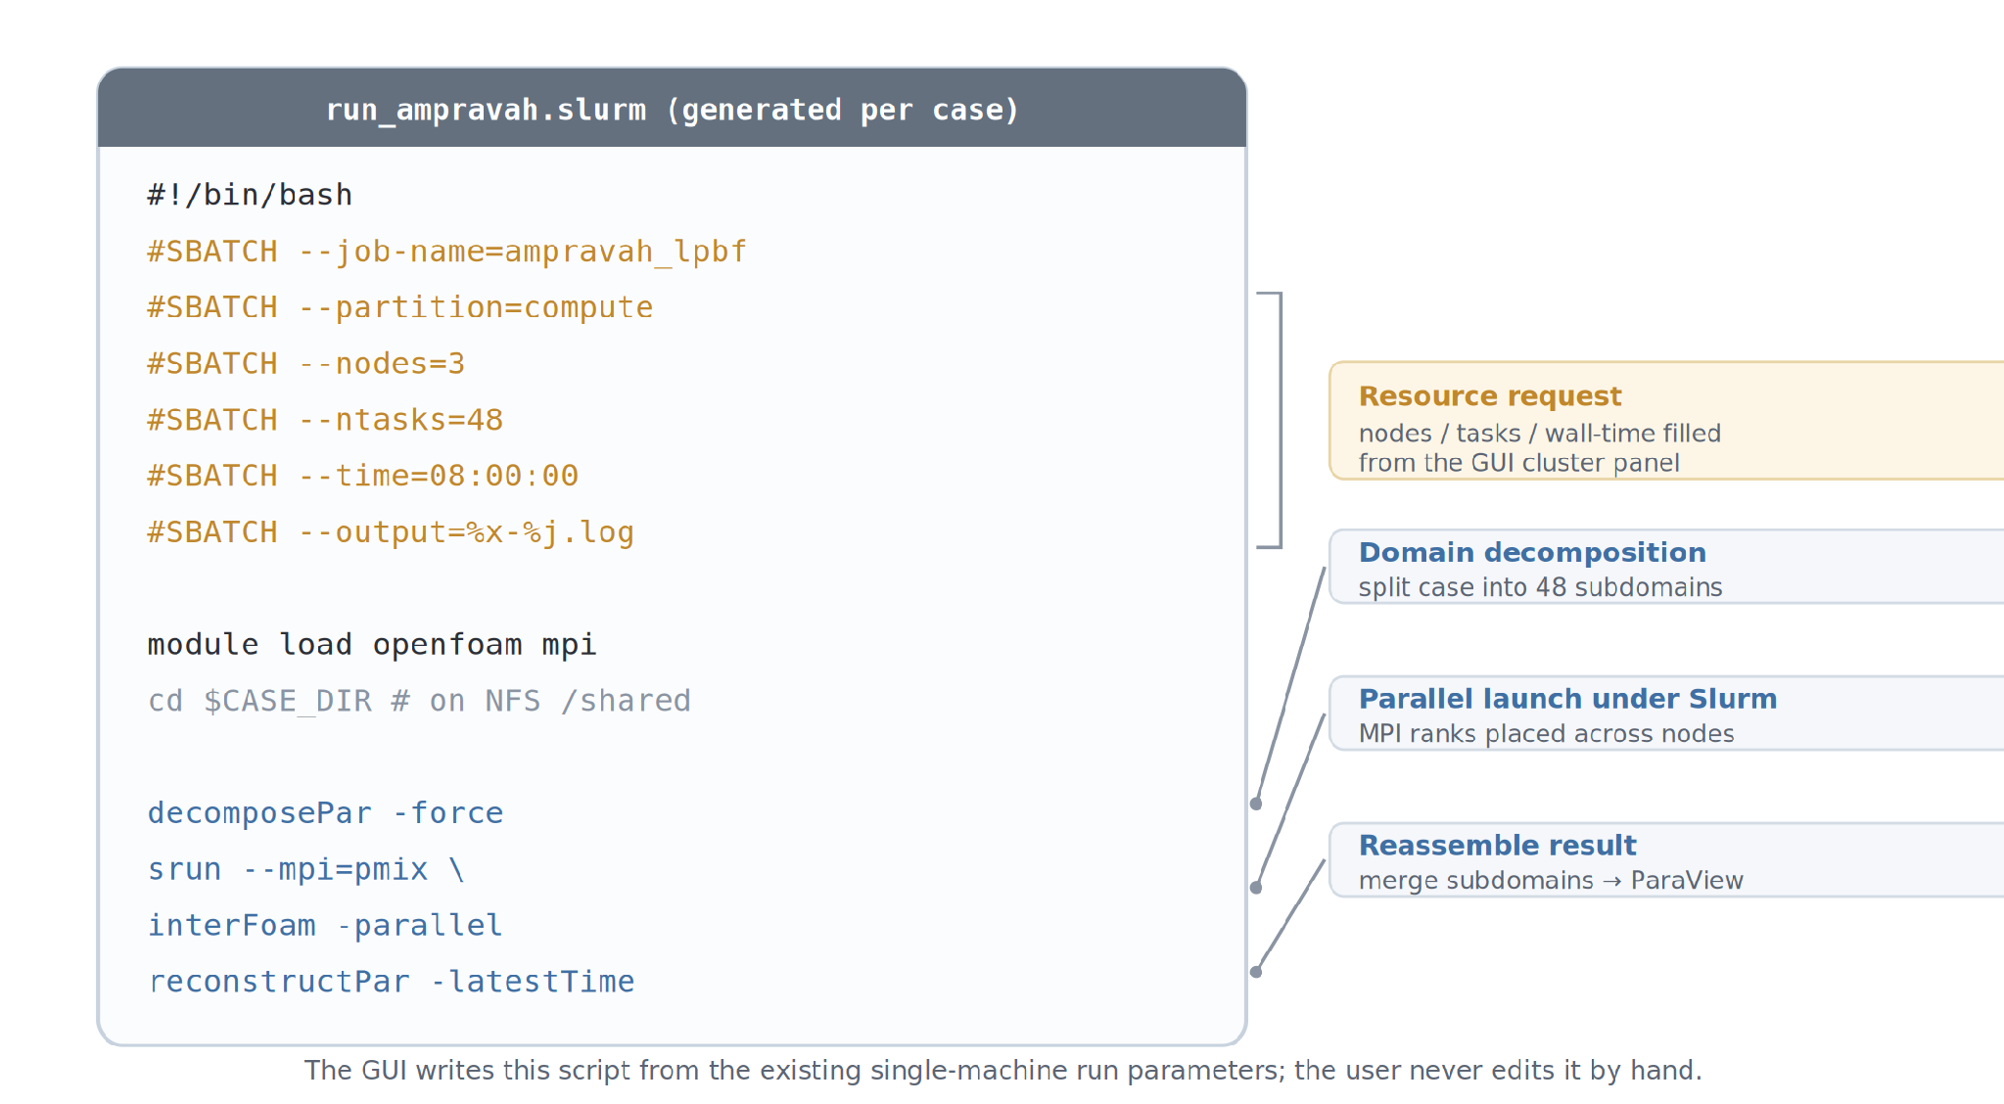
Figure 4.10: Anatomy of the SLURM batch script generated per case, resource request, domain decomposition, parallel launch, and reassembly.
The generated script encodes, per case, the complete recipe for a distributed run. A block of #SBATCH directives declares the job name, the target partition, the number of nodes and tasks, the wall-time limit, and the log destination, all populated from a small cluster panel added to the GUI. The body of the script then decomposes the case into as many subdomains as there are requested tasks (decomposePar), launches the solver in parallel across the allocated nodes under SLURM's process launcher (srun / mpirun), and finally reassembles the per-subdomain results into a single case (reconstructPar) ready for the existing post-processing pipeline. The subdomain count is always kept equal to the task allocation SLURM actually grants, so the decomposition matches the resources in hand rather than an assumed figure.
Submission was made asynchronous, which was a necessary change in execution model. The backend submits the script with sbatch, captures the returned job identifier, and then polls the job's state (via squeue and sacct), streaming the SLURM log back into AM PravaH's existing progress panel. The user therefore continues to see the same familiar stage-by-stage feedback, powder spreading, CFD on a given layer, and so on, whether the job is executing locally or out on the cluster.
C. The single-system / cluster toggle
The two backends are exposed to the user as a single toggle in the run dialog, illustrated in Figure 4.9. With the toggle off, AM PravaH runs in Single System mode, the original, default, unchanged local path, and the cluster controls stay hidden. With the toggle on, HPC Cluster mode is selected and a compact panel appears for the node count, tasks per node, partition, and wall-time. Because everything above the Run action is shared between the two modes, a case defined once can be dispatched to a laptop for a fast sanity check or to the cluster for the full production build, and the two runs remain directly comparable.
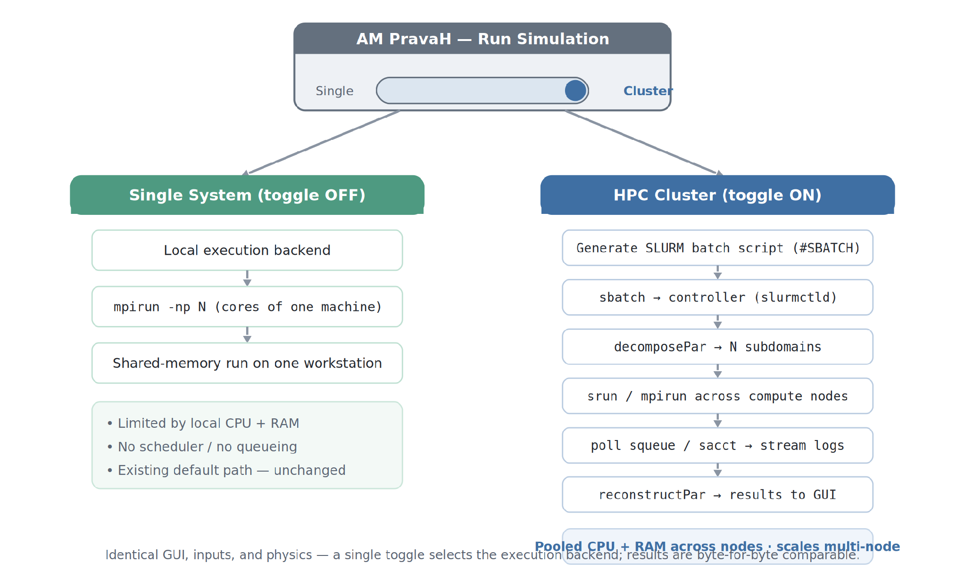
Figure 4.9: The run toggle selecting between the unchanged single-system path and the distributed cluster path; inputs and physics are identical on both sides.

4.1.3 Specific Challenges Encountered
Several categories of problem consumed most of the development effort, and each fed directly into the operational documentation that now accompanies the cluster.
- MUNGE authentication failures: the earliest cross-node submissions failed with credential errors. The causes were the two classic ones, unsynchronised node clocks (MUNGE credentials expire within minutes, so even modest skew is fatal) and a stale key on one node. Enforcing time synchronisation across the cluster and re-distributing an identical key with the correct ownership and permissions resolved it, and both checks became part of a standard pre-flight routine.
- Matching decomposition to allocation: an early mismatch between the number of OpenFOAM subdomains and the number of tasks SLURM had granted left cores idle in some runs and oversubscribed the job in others. Deriving the decomposition directly from the granted allocation eliminated the class of bug entirely.
- Shared-path assumptions: the case directory had to resolve to the same absolute path on every node. A node that mounted the shared filesystem at a different location produced “file not found” errors partway through a run, standardising the mount path across the cluster fixed it.
- Decoupling submission from execution: the original single-machine path ran the solver synchronously and simply blocked until it finished. On a shared cluster a job may sit in a queue behind others, so the backend had to move from “run and wait” to “submit and poll,” driving the GUI from reported job state rather than from a live process it owned directly.
- Preserving single-system behaviour: the firm requirement was that switching the toggle off must reproduce the earlier results exactly. Keeping single-node runs on the original local code path, rather than quietly routing them through SLURM, guaranteed that the addition of cluster support changed nothing for existing users.

4.6.4 Outcome
AM PravaH's LPBF module now runs unchanged on a single workstation and scales across a multi-node HPC cluster, with the choice made by a single toggle and no change whatsoever to the inputs, the physics, or the user experience. Large multi-track and multi-layer cases that previously saturated one machine's cores and memory can now be distributed across the cluster, pooling CPU and RAM; wall-clock time falls broadly in proportion to the cores added, subject to the usual limits of parallel efficiency, and cases too large to fit in a single machine's memory become runnable for the first time.
Beyond the feature itself, the cluster provisioning recipe (SLURM, MUNGE, SSH, and the shared filesystem) and the pre-flight checklist distilled from the debugging above were documented internally, so the cluster can be reprovisioned or extended with additional compute nodes without rediscovering the same failure modes. This module extended AM PravaH from a single-machine tool into one that can grow with the computational demands of the builds its users need to simulate.

4.2 Module 3, Cross-Platform Porting via WSL 2

4.2.1 Problem Definition
AM PravaH was a Linux-native application, every solver in its stack assumed a POSIX environment with specific Linux kernel features, and the development team's reference platform was Ubuntu 22.04. However, the vast majority of SM Engineers' industrial customers ran Windows on their engineering workstations. The existing options for these customers, dual-boot Linux, full virtual machines, or remote Linux servers, were each unattractive for different reasons: dual-boot required IT department approval and a workflow disruption, full VMs were slow and resource-heavy, and remote servers introduced latency and network dependency.
WSL 2 changed the calculus. By providing a real Linux kernel inside a managed Hyper-V virtual machine, integrated transparently with the Windows file system and (via WSLg) with the Windows display server, WSL 2 enabled AM PravaH to run on Windows essentially unmodified at the solver level, with the host Windows providing the user-facing experience.

4.2.2 Implementation Approach
The port was structured as an automated installer rather than a manual procedure, because asking a mechanical engineering customer to type wsl --install commands would have defeated the purpose. The installer is a Python automation script wrapped inside a Windows binary executable (.exe), produced using PyInstaller, that the customer can run with a double-click.
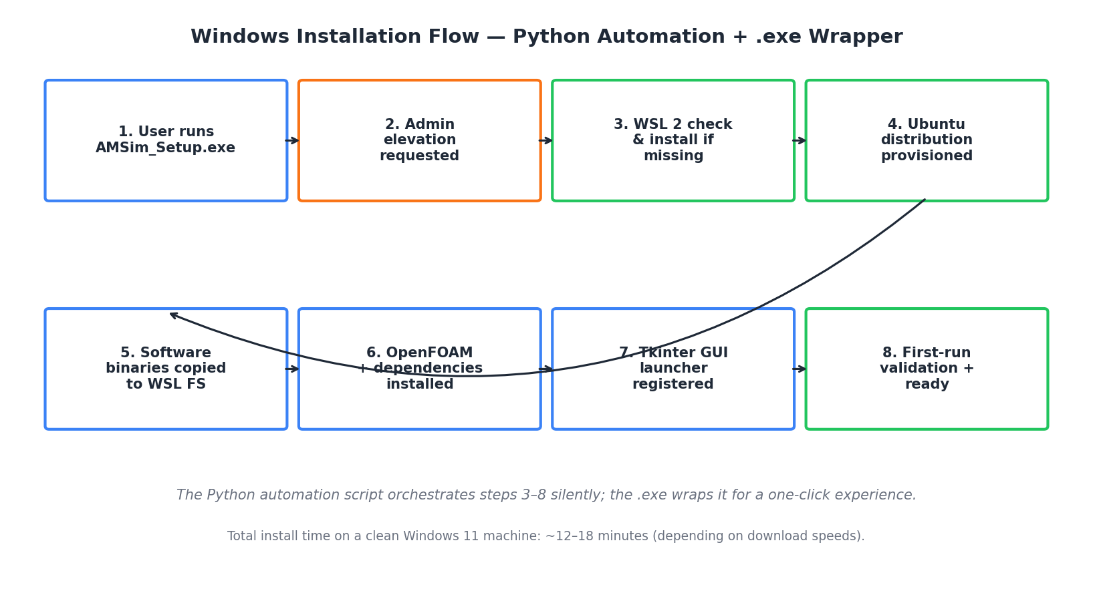
Figure 4.3: Eight-stage installation flow executed silently by the .exe wrapper.
The installer performs the following operations in sequence, each with appropriate error handling and rollback logic:
- Elevates to administrator privileges via UAC; aborts gracefully if denied.
- Detects the presence and version of WSL 2 on the host system. If absent or outdated, runs wsl --install with progress reporting.
- Provisions a dedicated Ubuntu 22.04 distribution named AM PravaH-wsl, separate from any existing WSL distributions the user may have.
- Copies the AM PravaH software binaries from a bundled archive into the WSL file system, placing them under /opt/AM PravaH/.
- Installs the required OpenFOAM version, Python dependencies, ParaView, and supporting libraries inside the WSL distribution via apt and pip.
- Registers a Windows Start Menu shortcut that launches the AM PravaH GUI by invoking the Linux-side launcher through WSLg, presenting the Tkinter window as if it were a native Windows application.
- Runs a first-time validation that opens a tiny built-in test case end-to-end, confirming that the solver, UI, and post-processing all function correctly.
- Writes a structured installation log to the user's AppData folder for future troubleshooting.

4.2.3 Specific Challenges Encountered
Three categories of issues consumed most of the development time. First, BIOS-level virtualization disabled by default on many corporate-supplied laptops, the installer had to detect this condition and present clear remediation instructions rather than a cryptic kernel error. Second, corporate antivirus solutions that aggressively quarantined the .exe wrapper; signing the executable and submitting it for false-positive review with major vendors became part of the release process. Third, conflicts when the user already had a different WSL distribution installed for unrelated purposes, the dedicated AM PravaH-wsl distribution name was specifically chosen to avoid this.
Total install time on a clean Windows 11 machine, measured during validation, was 12 to 18 minutes depending primarily on internet download speeds for OpenFOAM and dependencies.

4.2.4 Outcome
The Windows port was made available to existing Linux customers as an alternative deployment target in late February and to new Windows-only customers from March onward. By the end of the internship, a substantial fraction of new client installations were on Windows, a customer segment that had previously been entirely unaddressed.

4.3 Module 1, Tkinter UI Refinement for Improved Usability

4.3.1 Problem Definition
AM PravaH's pre-existing GUI had grown over several developer generations. New panels, dialogs, and buttons had been added piecemeal as features were introduced, with no central design language. End-users reported three recurring complaints during onboarding sessions: it was unclear which fields were mandatory versus optional, the visual hierarchy did not match the conceptual workflow (geometry first, then material, then process parameters), and long-running simulations gave no visible feedback, leading users to suspect crashes and force-quit perfectly healthy runs.

4.3.2 Implementation Approach
Rather than rewriting the GUI from scratch (which would have been outside the scope of an internship-length task and would have invalidated existing user training), the approach was incremental refinement aligned with three principles: visual consistency, explicit affordance, and continuous feedback.
- Visual consistency: A single ttk style file was introduced that centralized fonts, padding, button colors, and frame borders. Every dialog and panel was updated to consume this style file instead of declaring its own visual properties inline.
- Explicit affordance: Input panels were restructured into clearly labeled sections (Geometry, Material, Process, Output) following the user's mental workflow. Mandatory fields were marked with a leading asterisk, and the parameter forms gained inline validation messages that appeared next to a field as soon as an invalid value was entered.
- Continuous feedback: A progress indicator system was added that surfaces solver-stage information ("Preparing case", "Spreading layer 3 of 8", "Running CFD on layer 2", and so on), making it visually obvious that the system is alive and progressing rather than hung.
Tooltips were added to every non-obvious control, leveraging a small custom tooltip widget that worked uniformly across all ttk widgets, a small but disproportionately impactful addition, particularly for new users encountering domain-specific terminology like "hatch spacing" or "layer thickness" for the first time.

4.3.3 Outcome
The refined UI was rolled out incrementally, first to the internal Applied team for validation against their typical workflows, then to a small set of pilot customers. Onboarding-call durations for new client installations dropped noticeably during March and April, and the volume of "is it stuck?" support questions during long simulations effectively disappeared once progress indicators were live.

4.4 Module 5, Docker-Based Cross-Platform Deployment

4.4.1 Problem Definition
Even after the WSL 2 port had successfully addressed Windows customers, two gaps remained. First, macOS customers, though smaller in number, they included several university research labs, had no supported deployment path at all. Second, Linux customers were still responsible for installing and maintaining the long dependency chain of AM PravaH themselves, with all the version-skew risks that implies. Docker offered a single mechanism that could address both.
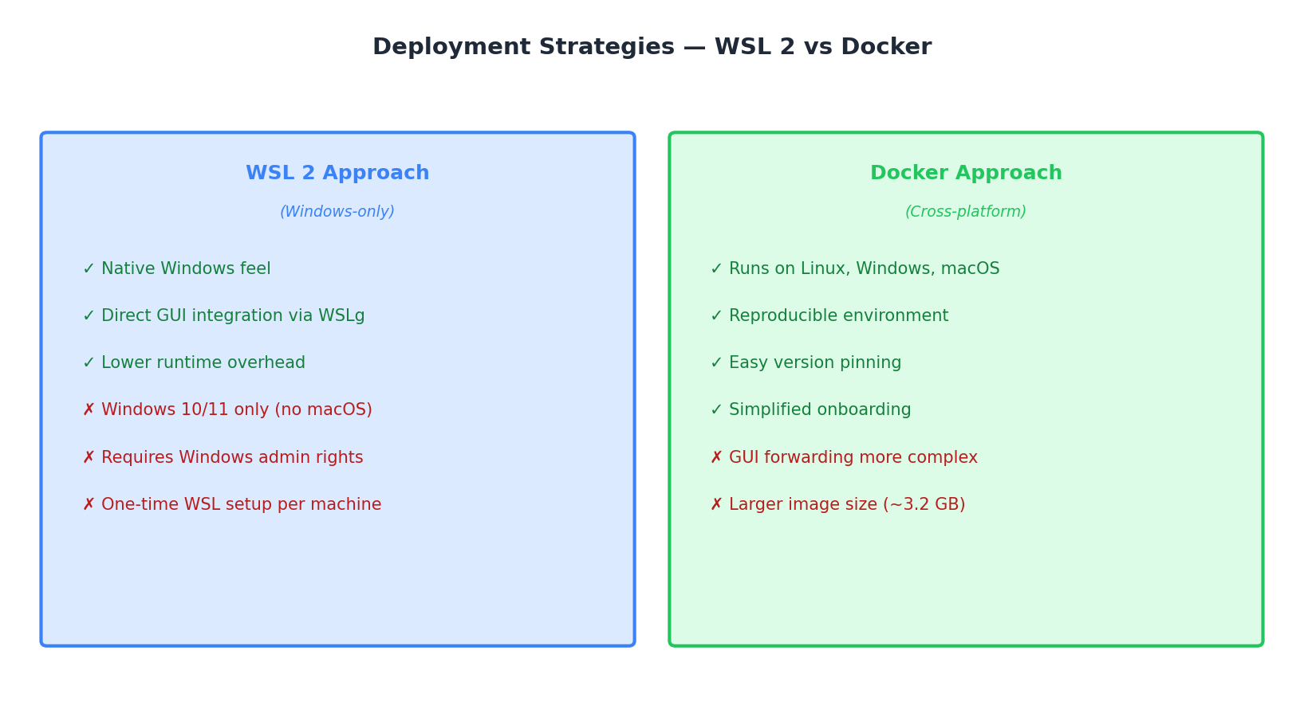
Figure 4.7: Comparison of the WSL 2 and Docker deployment strategies.

4.4.2 Implementation Approach
The Docker work was structured around a multi-stage Dockerfile. The first stage starts from an Ubuntu 22.04 base, installs the build-time dependencies, compiles and configures OpenFOAM, and stages all heavy artifacts. The second stage starts from a minimal runtime base and copies only the runtime artifacts from the first stage. This multi-stage approach reduced the final image size by approximately 40% compared to a single-stage build.
The technically interesting challenge with the Docker work was GUI forwarding, Tkinter expects to talk to a display server, and containers do not have one by default. On Linux, this was solved by mounting the host's X11 socket into the container. On Windows, the Docker Desktop integration with WSLg made this work essentially identically to the WSL 2 port. On macOS, an external X11 server (XQuartz) had to be configured by the user as a prerequisite, with the installation steps documented in a setup guide.
Image versioning followed a strict tag convention: stable-{semver} for production releases, dev-{git-sha} for development builds, and latest aliased to the most recent stable. A simple docker run --gpus all command (on systems with NVIDIA GPUs) enabled GPU-accelerated solver runs where the underlying hardware supported it.

4.4.3 Outcome
The Docker image was released as the recommended deployment path for Linux power-users and for macOS users, and as an alternative deployment path for Windows users who preferred container workflows. The final image size came in at approximately 3.2 GB, which was acceptable given the substantial scientific computing stack it bundles. Reproducibility issues, clients running slightly different versions of the same software and producing slightly different results, effectively disappeared for the customers who adopted the Docker deployment.

4.5 Module 4, Dynamic Bed Volume and Pack Density Modeling

4.5.1 Problem Definition and Background Physics
Powder-bed additive manufacturing builds a metal part by alternating two operations: a thin layer of metal powder (typically 30 to 100 micrometers thick) is spread uniformly across a build platform by a moving spreader (recoater) blade; then a laser scans the cross-section of the part on that powder layer, fusing the powder grains into a solid section of the final part. After laser scanning, the platform descends by one layer thickness and the cycle repeats.
The simulation models four interacting components: the platform (the underlying build plate that descends one layer thickness between layers), the substrate (an initial solid material on which the first layer is deposited), the powder (the granular metal material being spread), and the spreader (the recoater blade that distributes the powder).
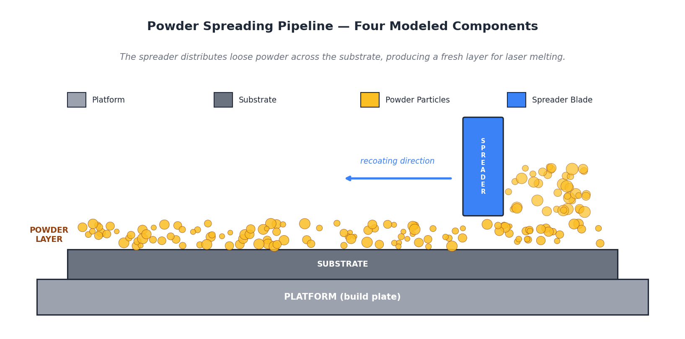
Figure 4.4: The four modeled components of the powder spreading module.
The pack density of a powder layer is the ratio of the volume of solid metal particles in the layer to the total volume that the layer occupies (including the void spaces between particles). It is dimensionless, typically lies between about 0.55 and 0.65 for well-spread metal powders, and directly determines how much material is available to be fused in the subsequent laser scan.

4.5.2 Implementation Approach
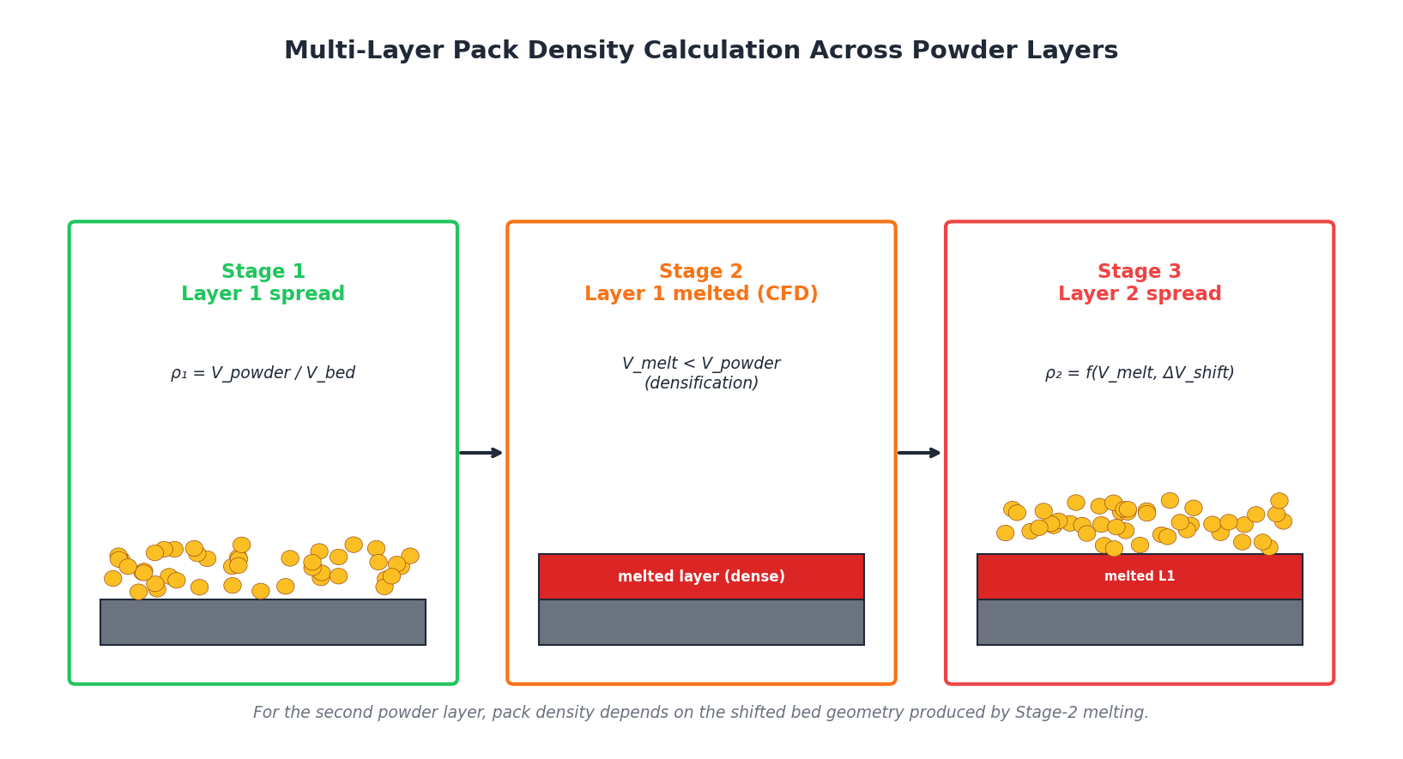
Figure 4.5: Three-stage representation of multi-layer pack density evolution.
The implementation proceeded in three logical stages, mirroring the physical process:
- Stage 1, First-layer pack density: Computed directly as ρ₁ = V_powder / V_bed, where V_powder is the total volume of particles produced by the DEM spreading simulation, and V_bed is the geometric volume of the layer (planar area times layer thickness).
- Stage 2, Melt-induced volumetric change: After the CFD solver melts the first layer, the consolidated solid volume V_melt is extracted from the solver output. Because liquid metal occupies less volume than the loosely packed powder it came from, V_melt is consistently less than V_powder, and the difference (V_powder − V_melt) is the densification gain for that layer.
- Stage 3, Second-layer pack density on a shifted bed: When the second powder layer is spread, the available bed volume is no longer the simple planar layer-thickness volume, it is the layer-thickness volume plus the shift introduced by the prior layer's densification. The algorithm I implemented computes this updated bed volume by combining V_melt with the new layer's nominal volume, accounting for the non-uniform surface profile produced by the melt.
The geometric work required to compute the shifted-bed volume is the analytically most demanding part. In practice, it involves discretizing the melted-layer surface into a triangulated mesh, computing the height field of the new layer's free surface above this mesh, and integrating to obtain a volume. NumPy and SciPy provided the underlying linear algebra and computational geometry primitives; the algorithm itself was implemented in Python for maintainability, with the inner loops vectorized for performance.

4.5.3 Results and Validation
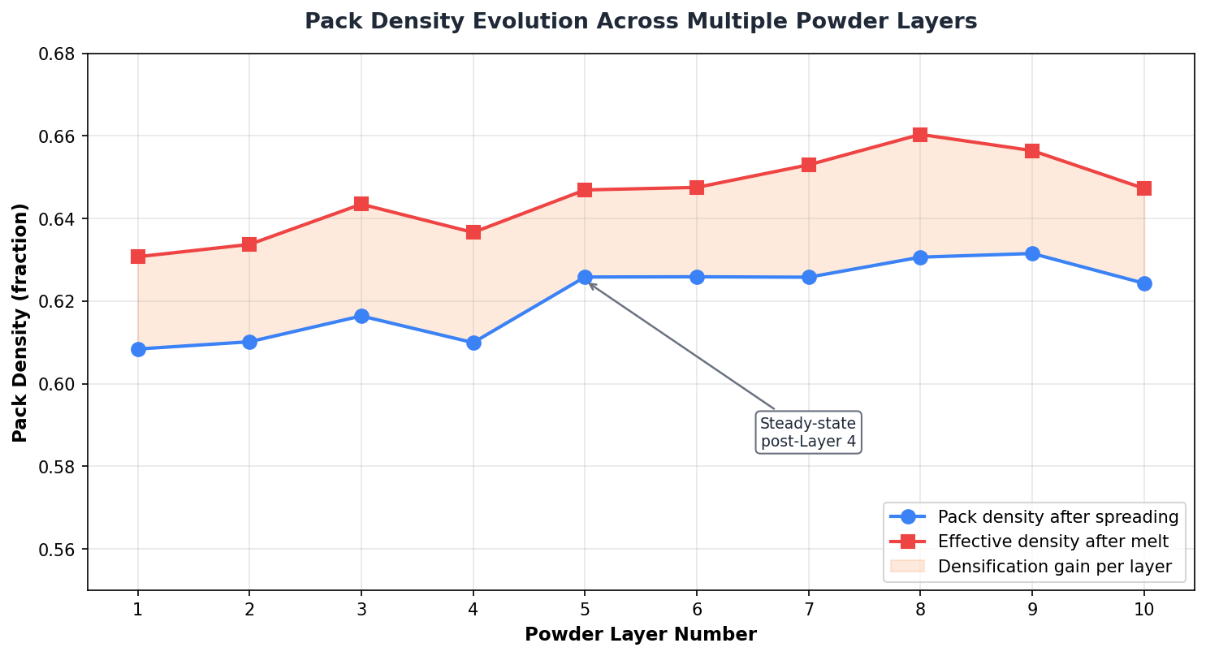
Figure 4.6: Pack density evolution across ten simulated powder layers, showing densification gain per layer.
The implementation was validated against reference simulations whose expected pack density values were already known from earlier Applied team work, and against experimental densification measurements from the company's in-house additive manufacturing samples. The pack density typically rises from approximately 0.58 in the first layer to a steady-state value around 0.625 by the fourth or fifth layer, with the densification gain per layer (the difference between pre-melt and post-melt density) being approximately 2 to 3 percentage points.
This steady-state behavior is physically expected, once the surface profile beneath the new powder layer reaches a quasi-stable form, the geometric contribution to pack density variation diminishes, and subsequent layers behave very similarly to each other. Reproducing this behavior in simulation served as an indirect validation of the implementation's correctness.

4.5.4 Outcome
The multi-layer pack density module was integrated into the main solver pipeline and is now used in every multi-layer simulation run by AM PravaH. Prior to this work, multi-layer simulations had to assume a constant pack density across all layers, which was known to introduce systematic errors in the predicted thermal behavior of the upper layers. With the new implementation, layer-specific pack density is propagated correctly through the simulation, improving the fidelity of the thermal predictions for builds taller than a few layers.

4.6 Module 2, Merging New Solver Features into Updated UI Branch

4.6.1 Problem Definition
During the period that Module 1 was in progress, the Applied team had been actively developing two new physics modules on the legacy/v2.x branch: a Fluid Dynamics module that more accurately models melt-pool fluid behavior under laser heating, and a Spreader Creation module that allowed users to define custom spreader (recoater) blade geometries and motion profiles. These were valuable features that needed to reach customers, but they had been built against the older UI conventions of v2.x and could not simply be merged forward, the underlying Tkinter widgets, frame layouts, and event-handling conventions had all changed in v3.0-ui.
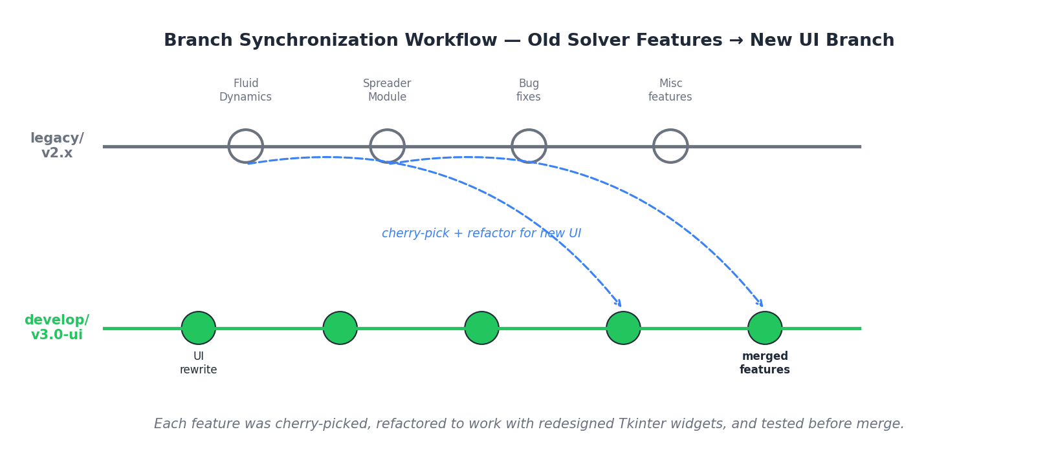
Figure 4.2: Cherry-pick-and-refactor workflow used to bring legacy solver features into the new UI branch.

4.6.2 Implementation Approach
The work was structured as a series of cherry-pick-and-refactor cycles rather than a single large merge. For each feature, the process was:
- Identify the minimal set of commits on legacy/v2.x that implemented the feature, separating solver-side changes (largely portable) from UI-side changes (almost entirely non-portable).
- Cherry-pick the solver-side commits onto a feature branch off develop/v3.0-ui.
- Rewrite the UI-side integration from scratch against the new Tkinter widget conventions, reusing the central style file and validation patterns established in Module 1.
- Add a regression test case for the integrated feature using a small reference simulation whose expected output was already known from the legacy branch.
- Open a pull request, address review comments, and merge once both UI and solver behavior were validated.

4.6.3 Specific Challenges Encountered
The Fluid Dynamics module presented a particularly interesting integration challenge: it consumed temperature-field data that, in the legacy UI, was passed via a global state object that no longer existed in v3.0-ui. The fix required introducing a small explicit interface between the solver and the application layer, which had the side benefit of decoupling the module from any specific UI implementation, a pattern that was subsequently reused for future integrations.
The Spreader Creation module required coordination with the Applied team on a subtle physical issue: the legacy implementation assumed a rigid spreader blade, while the new module allowed for slight blade deflection under load. Confirming the correct behavior required two design discussions and a small calibration run against a reference experimental measurement.

4.6.4 Outcome
Both modules were merged into the v3.0-ui branch and made available to internal Applied team members for use in their validation work. The cherry-pick workflow used here became a reusable template, documented in the team's internal Confluence page, for handling any subsequent legacy-to-new-branch migrations.

5. RESULTS AND DISCUSSION

5.1 UI Refinement: Outcomes
Module 1 reduced onboarding friction for new customer installations. Feedback from both internal users and customer-facing team members was consistent: the refined UI was perceived as more professional and less intimidating for first-time users. The progress-indicator system eliminated the "is it stuck?" support tickets that previously arose during long CFD runs. A secondary outcome was the centralized ttk style system, which made subsequent feature additions by other developers substantially faster.

5.2 Solver Feature Integration: Outcomes
Both the Fluid Dynamics and Spreader Creation modules were successfully integrated into the develop/v3.0-ui branch and made available for production use. The cherry-pick-and-refactor workflow was documented as a reusable template and has since been used by other developers without further coordination. A meaningful side-effect was the introduction of an explicit interface between the Fluid Dynamics module and the application, decoupling them for easier future modifications.

5.3 WSL 2 Windows Port: Outcomes
The port opened up the Windows customer segment, previously inaccessible without significant manual effort. The automated installer made deployment comparable to installing a commercial Windows application, with no command-line interaction required. Pre-flight checks added in response to OnCall findings reduced the failure rate during installation and noticeably cut escalations.

5.4 Pack Density Modeling: Outcomes
The multi-layer pack density module was the most analytically involved work and the single most useful technical contribution to AM PravaH. Prior multi-layer simulations had assumed constant pack density across all layers, introducing systematic errors that grew with layer count. The trajectory, rising from ~0.58 in the first layer to a steady-state ~0.625 by layer four or five, matches both powder-mechanics theory and the company's experimental observations, serving as indirect validation.

5.5 Docker Deployment: Outcomes
The Docker image provides reproducible deployment across Linux, Windows, and macOS, addressing the macOS gap that WSL 2 could not cover. It is the recommended deployment for customers requiring strict version control, typically academic research groups and regulated industries. The final image size of approximately 3.2 GB is acceptable given the bundled stack.

6. CHALLENGES AND LEARNINGS FROM THE INTERNSHIP
This chapter documents the most substantive challenges encountered during the internship and the corresponding learnings, framed as paired Challenge/Learning observations grounded in specific situations.

6.1 Bridging Software and Physics
Challenge: In the first three weeks, the technical discussions with the Applied team were genuinely difficult to follow. Terms like "melt pool dynamics", "Marangoni convection", "sintering necks", and "keyhole instability" were entirely routine within the team, and acronyms (DEM, MPM, CFD, LPBF) layered onto one another. Almost every implementation decision had a physical interpretation that could make it correct or incorrect, so the work could not be properly done without understanding the underlying physics.
Learning: Technical language in any specialized industry is a compression tool, it allows experienced people to communicate precisely and quickly, at the cost of being initially impenetrable to newcomers. The fastest way to become fluent is to accept that confusion is a necessary phase, build a personal glossary systematically, and ask questions about underlying concepts rather than just definitions. By week five, I was participating meaningfully in design discussions; by week eight, I was occasionally proposing physical-reasoning arguments rather than just receiving them.

6.2 Working with Confidential and Proprietary Code
Challenge: Significant portions of AM PravaH, particularly in the solver layer, represent years of accumulated proprietary work treated as commercial secrets by the company. Reading and modifying such code requires a different posture than working with open-source software: you cannot post snippets to forums for help, you cannot publish your work, and informal discussion outside the team is restricted.
Learning: Internal documentation, in-team mentorship, and rigorous self-reading of unfamiliar code (using a debugger as a learning tool rather than just a problem-finding tool) become the primary mechanisms for understanding. This style of work feels slower at first compared to the always-Google-able experience of typical academic software development, but it produces a depth of internalized understanding that is genuinely valuable.

6.3 Debugging Across Layers
Challenge: When something went wrong in a multi-layer simulation, say, a clearly incorrect pack density value in the third layer, the bug could in principle live in the UI, the application orchestrator, the solver itself, or the OS/runtime layer. Localizing such bugs across five layers of the architecture stack was, in the first month, frequently overwhelming.
Learning: Disciplined logging at every layer boundary is far more important than I had previously appreciated. A log entry at each handoff point converts a multi-layer bug-localization problem into a much simpler problem of finding where the values diverged from expectation. I came to think of logging not as a debugging aid but as a primary architectural decision, on par with choosing data structures or interfaces.

6.4 Managing OnCall Pressure
Challenge: The first OnCall rotation in February was genuinely stressful. A customer's installation failed mid-deployment due to a corporate antivirus flagging the .exe wrapper, and I had to coordinate a response that involved both technical investigation and customer relationship management, both pressures operating simultaneously.
Learning: In a customer-facing technical role, the technical fix and the customer communication are not separable concerns, an excellent technical fix delivered with poor communication can damage the relationship as much as a slow fix would. I learned to communicate proactively about diagnostic progress rather than going silent during a long investigation. This pattern significantly reduced the perceived response time even when actual resolution times were unchanged.

6.5 Writing Code That Other People Will Read
Challenge: My early pull requests received review comments that, in retrospect, were entirely fair, code that worked but was difficult to follow, assumptions that were correct but not documented, function names that I understood but no one else would. The first round of these comments was uncomfortable; the impulse was to defend the code rather than absorb the feedback.
Learning: Code review is a form of communication, not a critique of competence. Reviewers are testing whether future maintainers will be able to work with the code. Internalizing this reframing made review feedback substantially easier to receive and act on. By the third month, my pull requests were getting through review faster, primarily because the failure modes that earlier reviews had taught me to anticipate were no longer present in the code I submitted.

6.6 Pace, Discipline, and Professional Adjustment
Learning: The most general adjustment required was not technical, it was the shift from academic-pace work, where deadlines are episodic and largely self-set, to industry-pace work, where small commitments accumulate continuously and the bar is consistent reliable delivery rather than occasional brilliant submissions. By month three, I had internalized this rhythm sufficiently to be tracking my own work proactively rather than being reminded; by month five, I was occasionally identifying upstream issues before they surfaced as explicit asks. This professional habit, more than any specific technical skill, is what I expect to carry forward into post-graduation work.

7. OUTCOME
The most significant outcome of this internship was the development of a working sense for how industrial software is actually built and shipped. Before joining SM Engineers, my understanding of software engineering was shaped primarily by coursework and personal projects, where the artifact is a self-contained program and the standard of success is that it works on the developer's own machine. The internship replaced that impression with something more accurate: that industrial software lives inside a system of physical realities, customer constraints, and operational discipline, and that the developer's job is to deliver something that survives this larger context rather than just to produce working code in isolation.
Specifically, the internship produced the following durable outcomes:
- Production Software Engineering Practice: I developed working competence in the full lifecycle of feature development in a small-team commercial product, designing changes, implementing them, getting them through code review, validating them against reference cases, and shipping them to real customers. The end-to-end nature of this experience cannot be reproduced in any single academic course.
- Scientific Software Domain Knowledge: I gained genuine working knowledge of the additive manufacturing simulation domain, what powder-bed fusion is, how DEM and CFD solvers work together to model it, what pack density means and why it matters, and how multi-layer builds differ from single-layer builds. This is specialized knowledge that has direct applicability in the broader scientific computing and computational engineering industries.
- Cross-Platform Deployment Expertise: The combined WSL 2 and Docker work gave me hands-on experience with the operational side of software, how installers are built, how environments are reproduced, how customer support is structured, and how deployment decisions shape who can use a product at all. This intersection of software engineering and operations is increasingly central to modern industry roles.
- Working with Confidentiality and Proprietary Systems: I developed the professional habits required for working with sensitive code, disciplined internal documentation, careful escalation, and respect for commercial boundaries. These are not skills typically taught explicitly but are universally required in any industrial software role.
- Customer-Facing Technical Maturity: The OnCall rotation gave me direct experience with customer communication during high-pressure situations, teaching me to balance technical investigation with proactive status communication. This is a skill that compounds over a career.
If distilled into a single sentence: the internship taught me that the distance between writing code and shipping product is not bridged by writing more code, it is bridged by attention to deployment, to documentation, to user experience, to support, and to the discipline of treating one's own software as something other people will have to live with. That perspective is the most valuable thing I take away from the six months at SM Engineers.

8. REFERENCES
- Paanduv Application Pvt. Ltd. Internal Technical Documentation, AM PravaH Developer Guide (v3.0-ui), 2026.
- OpenFOAM Foundation, OpenFOAM User Guide, https://www.openfoam.com/documentation
- Microsoft, Windows Subsystem for Linux Documentation, https://learn.microsoft.com/en-us/windows/wsl/
- Docker Inc., Docker Engine Reference Documentation, https://docs.docker.com/
- Python Software Foundation, Tkinter Documentation, https://docs.python.org/3/library/tkinter.html
- Kitware Inc., ParaView User's Guide, https://docs.paraview.org/
- NumPy Community, NumPy Reference Manual, https://numpy.org/doc/
- Cundall, P. A. and Strack, O. D. L., "A Discrete Numerical Model for Granular Assemblies," Geotechnique, 29(1), 47-65, 1979.
- Sulsky, D., Chen, Z., and Schreyer, H. L., "A Particle Method for History-Dependent Materials," Computer Methods in Applied Mechanics and Engineering, 118(1-2), 179-196, 1994.
- Khairallah, S. A. et al., "Laser Powder-Bed Fusion Additive Manufacturing: Physics of Complex Melt Flow and Formation Mechanisms," Acta Materialia, 108, 36-45, 2016.
- Industry surveys and technical white papers on metal additive manufacturing market trends, 2024-2026.

